8th December 2025
Company Management at the GEMÜ Group is being restructured

To boost the GEMÜ Group’s international presence and make customers an even greater priority, the Hohenlohe-based valve specialist reorganized its Company Management in November 2025. Stephan Gehrig is a new addition to Company Management at the GEMÜ Group as the new Managing Director of Sales and Marketing.

Gert Müller, GEMÜ Group CEO and Managing Partner, has appointed new members to Company Management at the GEMÜ Group: In addition to Stephan Müller, Chief Financial Officer (CFO), Matthias Fick, previously Managing Director of Global Operations at GEMÜ Germany, joined the group’s management team in November 2025. He is taking on the role of Chief Operating Officer (COO) with the aim of improving the GEMÜ Group’s operational performance capability in the long term.
A new position has also been created – Chief Sales and Marketing Officer (CSMO) – and Stephan Gehrig has been appointed to Company Management at the group. Mr Gehrig brings with him considerable experience of management from a number of industrial companies. He has acquired valuable expertise in international sales and marketing in various management roles, which will serve him well in his new position at GEMÜ.
In taking this step, the company is centralizing management of all its national and international sales and marketing initiatives in order to take its focus on markets and customers to the next logical stage.
“By restructuring Company Management at the group to clearly focus on customer-centred activities, we are strengthening the strategic focal areas of the GEMÜ Group, putting the company in the best possible position for the future and furthering our international growth strategy. We offer our customers security, reliability and a straightforward approach to support them even when times are challenging,” explains Gert Müller, GEMÜ Group CEO and Managing Partner.

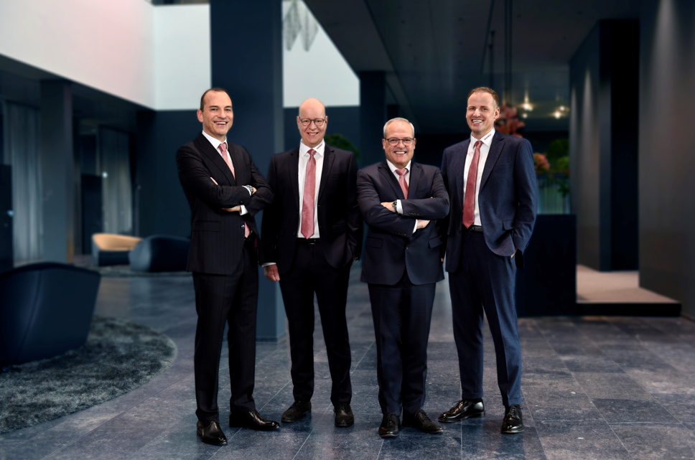
f.l.t.r.: Gert Müller, GEMÜ Group CEO and Managing Partner, Stephan Müller, Chief Financial Officer (CFO), Matthias Fick, Chief Operating Officer (COO), Stephan Gehrig, Chief Sales and Marketing Officer (CSMO)

About GEMÜ
The GEMÜ Group develops and produces valves, measurement and control systems for liquids, vapours and gases. The company is one of the global market leaders in sterile process applications. GEMÜ products are used in many different sectors – from pharmaceuticals, biotechnology and foodstuff production, right up to industrial processes and semiconductor production. The business achieved a turnover of more than 525 million euros worldwide in 2024.
The GEMÜ Group employs more than 2500 people and produces at eight locations worldwide. The company manages global sales through 25 subsidiaries and local partners, giving it a local presence in over 50 countries.
The internationally active group is managed by Gert Müller as CEO and Managing Partner, together with Stephan Müller (CFO), Matthias Fick (COO) and Stephan Gehrig (CSMO) as Managing Directors of the GEMÜ Group.
With customer-focused digital services and technical agility, the GEMÜ Group sets standards in process automation. Whether for media flows, the very highest hygiene standards or unique applications – the customer solutions are tailored to requirements, reliable and ready for use.
You can find further information at gemu-group.com.

