27th April 2026

Boosting efficiency, lowering costs:
GEMÜ is expanding the globe valve GEMÜ S40 series

Valve specialist GEMÜ is expanding globe valve GEMÜ S40 by actuator size 0, thereby adding another flexible solution for small nominal sizes and low operating pressures to the globe valve range of the latest product generation.

Globe valve GEMÜ S40 boasts a maintenance-friendly construction, a high level of operational safety and a compact, modern design. In addition to the actuator sizes 1 to 6 already available, the valve now also comes in the smallest size 0. This addition offers customers even more flexibility for a wide range of applications.

GEMÜ S40 is available for nominal sizes from DN 6 to DN 80 and for operating pressures from 0 to 40 bar. Actuator size 0 was specially developed for applications with a high switching frequency and enables rapid switching cycles even where space is limited, making it ideal for autoclaves or laboratory applications. The valve combines a compact design with efficiency and reliability – offering genuine added value for users.

The new actuator size 0 makes GEMÜ S40 even more flexible in use and emphasizes the consistent further development of GEMÜ’s latest product generation. This generation combines cutting-edge valves, smart automation solutions and innovative production methods, offering customers maximum adaptability, straightforward integration and space-saving applications.
You can find further information about the new product generation at leap.gemu-group.com.
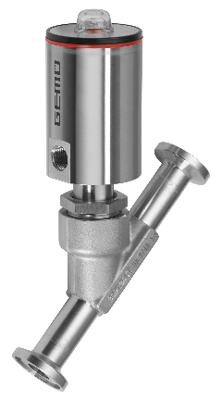

GEMÜ S40 with 44A0

About GEMÜ
The GEMÜ Group develops and produces valves, measurement and control systems for liquids, vapours and gases. The company is one of the global market leaders in sterile process applications. GEMÜ products are used in many different sectors – from pharmaceuticals, biotechnology and foodstuff production, right up to industrial processes and semiconductor production. The business achieved a turnover of more than 525 million euros worldwide in 2024.
The GEMÜ Group employs more than 2500 people and produces at eight locations worldwide. The company manages global sales through 25 subsidiaries and local partners, giving it a local presence in over 50 countries.
The internationally active group is managed by Gert Müller as CEO and Managing Partner, together with Stephan Müller (CFO), Matthias Fick (COO) and Stephan Gehrig (CSMO) as Managing Directors of the GEMÜ Group.
With customer-focused digital services and technical agility, the GEMÜ Group sets standards in process automation. Whether for media flows, the very highest hygiene standards or unique applications – the customer solutions are tailored to requirements, reliable and ready for use.
You can find further information at gemu-group.com.

