15th April 2026
GEMÜ headquarters receives “Best Workspaces Award 2026”

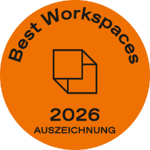
The GEMÜ Group’s headquarters in the Hohenlohe business park in Kupferzell has been awarded the prestigious “Best Workspaces Award 2026”. This makes the building one of the award-winning projects that are setting new standards for modern working environments across the German-speaking world.

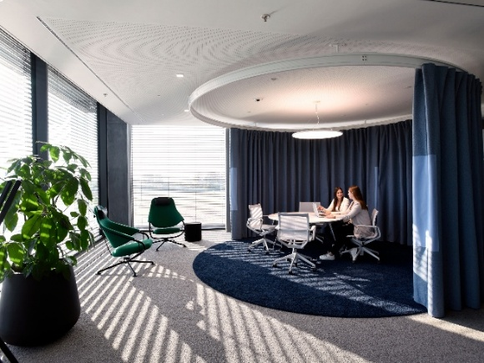
The “Best Workspaces Award” is one of the leading international architecture awards for smart working environments and office buildings. Each year, awards are presented to outstanding projects whose architectural quality, functional excellence and innovative concepts impress the competition’s jury. In 2026, around 70 projects were honoured, including exemplary solutions in the fields of interior design and structural engineering.
Judging the competition was an independent panel of experts from the fields of architecture, design, research and media. The key criteria included versatility, collaboration, communication, concentration and well-being, as well as the level of innovation, modernity and the architectural quality of the buildings.
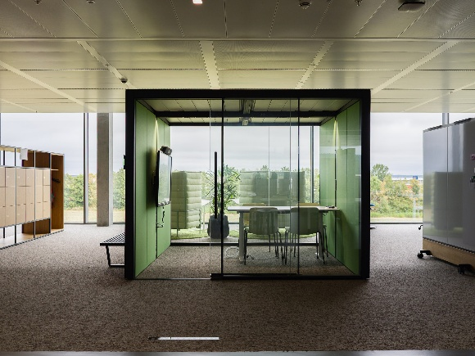
With its headquarters in Kupferzell, GEMÜ has created a working environment that goes far beyond traditional office design. The building combines functional requirements with a modern, employee-oriented configuration that is specifically intended to foster interaction, a sense of belonging and productivity. In doing so, GEMÜ has employed its holistic understanding of working environments, focusing on both the quality of the physical space and the subjective well-being of its employees. The interplay of architecture, functionality and workplace culture creates an environment that encourages communication and enables trailblazing working practices.

“For GEMÜ, a modern working environment is not just a ‘nice to have’, but a key factor in our success. In building our new headquarters, we have created an environment that fosters innovation, collaboration and job satisfaction in equal measure. “Open, versatile spaces, ergonomic workstations and quiet havens of inspiration not only boost productivity but also encourage creativity among our staff,” said Gert Müller, CEO and Managing Partner of the GEMÜ Group.
The award is organised by the Callwey Verlag publishing house in collaboration with leading partners from the fields of architecture, design and workplace research. The aim is to showcase ground-breaking workspace concepts and to encourage dialogue between companies, designers and manufacturers.

About GEMÜ
The GEMÜ Group develops and produces valves, measurement and control systems for liquids, vapours and gases. The company is one of the global market leaders in sterile process applications. GEMÜ products are used in many different sectors – from pharmaceuticals, biotechnology and foodstuff production, right up to industrial processes and semiconductor production. The business achieved a turnover of more than 525 million euros worldwide in 2024.
The GEMÜ Group employs more than 2500 people and produces at eight locations worldwide. The company manages global sales through 25 subsidiaries and local partners, giving it a local presence in over 50 countries.
The internationally active group is managed by Gert Müller as CEO and Managing Partner, together with Stephan Müller (CFO), Matthias Fick (COO) and Stephan Gehrig (CSMO) as Managing Directors of the GEMÜ Group.
With customer-focused digital services and technical agility, the GEMÜ Group sets standards in process automation. Whether for media flows, the very highest hygiene standards or unique applications – the customer solutions are tailored to requirements, reliable and ready for use.
You can find further information at gemu-group.com.

