9th February 2026
GEMÜ butterfly valves certified for hydrogen applications

Valve specialist GEMÜ has successfully had several butterfly valves certified in accordance with DIN EN 13774 and DVGW-CERT ZP4110. The test, which was conducted by the German Technical and Scientific Association for Gas and Water (DVGW), confirms that the valves are entirely suitable for use with hydrogen in a gaseous state.

The butterfly valves GEMÜ R480, R481, R487, R488 Victoria as well as GEMÜ R470, R471, R477 and R478 Tugela are suitable for operation with hydrogen. The certification applies to all body configurations and pressure ratings.

This makes GEMÜ butterfly valves suitable for a multitude of industrial applications in the hydrogen sector. They are used in electrolysis, PPE and fuel cell plants, as well as in distribution networks for isolating and controlling gas and liquid flows. They are also used in auxiliary processes such as treatment systems for cooling water, gas and water. In power-to-liquid plants, they enable precise control of hydrogen, CO₂ and synthesis gas flows in reactor and supply circuits.

The certified series comply with all technical requirements for hydrogen applications, including a compact design, short switching times and suitability for a wide range of media.
With certification complete, GEMÜ butterfly valves are now available for all applications in which hydrogen is used in a gaseous state. This means that customers can benefit from proven solutions for safely, reliably and efficiently operating hydrogen-based systems.
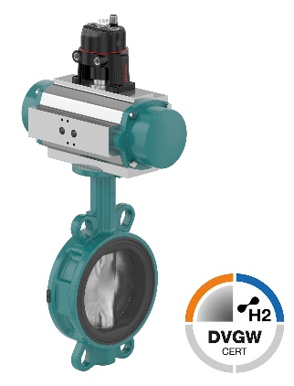

GEMÜ R481 Victoria with pneumatic quarter turn actuator and electrical position indicator
About GEMÜ
The GEMÜ Group develops and produces valves, measurement and control systems for liquids, vapours and gases. The company is one of the global market leaders in sterile process applications. GEMÜ products are used in many different sectors – from pharmaceuticals, biotechnology and foodstuff production, right up to industrial processes and semiconductor production. The business achieved a turnover of more than 525 million euros worldwide in 2024.
The GEMÜ Group employs more than 2500 people and produces at eight locations worldwide. The company manages global sales through 25 subsidiaries and local partners, giving it a local presence in over 50 countries.
The internationally active group is managed by Gert Müller as CEO and Managing Partner, together with Stephan Müller (CFO), Matthias Fick (COO) and Stephan Gehrig (CSMO) as Managing Directors of the GEMÜ Group.
With customer-focused digital services and technical agility, the GEMÜ Group sets standards in process automation. Whether for media flows, the very highest hygiene standards or unique applications – the customer solutions are tailored to requirements, reliable and ready for use.
You can find further information at gemu-group.com.

