15th September 2025

New GEMÜ multi-port valve block for single-use applications

Valve specialist GEMÜ is expanding its single-use range with the GEMÜ Multiport SUMONDO multi-port valve block. This is available with pneumatic or manual block locking.

GEMÜ Multiport SUMONDO combines several individual single-use diaphragm valves in one multi-port valve block, offering a new solution for applications in pharmaceutical and biotechnological industries. The tried-and-tested GEMÜ SUMONDO diaphragm valve principle ensures hermetic separation between the actuator and the medium by welding the diaphragm to the body. When using the GEMÜ Multiport SUMONDO, the actuator unit (multi-use) remains permanently installed in the plant, while the M-block (single-use) is replaced after use.

The compact M-blocks, which do not require tubes or piping between two seats, have a low hold-up volume in comparison with single valve solutions. This leads to greater process reliability and efficiency. Due to the compact design, less space is required in the plant. Production in accordance with GMP guidelines also ensures that the media wetted single-use M-blocks meet the highest standards in terms of purity, safety and stability.
Pneumatic or manual block locking
Two block locking options are available, which differ in the way the M-block (disposable) is connected to the actuator unit and offer either pneumatic locking (PSUA) or manual locking using a hand lever (PSUH). Both versions enable simple operation and fast replacement of the disposable between different production cycles.

The milled disposables can be manufactured in various designs, with different connections and sensor integrations for targeted use in the upstream and downstream area. This means that the M-blocks can be customised and implemented according to customer requirements.

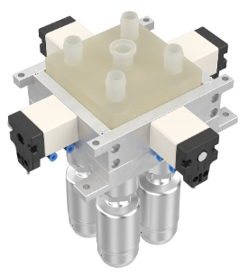
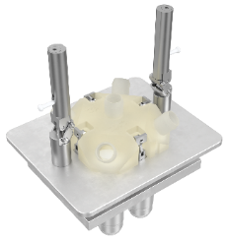

On the left: Actuator unit with pneumatic locking device (PSUA) with GEMÜ single-use M-block (KSUBA)
On the right: Actuator unit with manual locking device via hand lever (PSUH) with GEMÜ single-use M-block (KSUBH)

About us

The GEMÜ Group develops and manufactures valves, measurement and control systems for liquids, vapours and gases. GEMÜ is a global market leader when it comes to solutions for sterile applications.
The globally focused, independent family-owned enterprise was founded in 1964. In 2011, Gert Müller took over as Managing Partner together with his cousin Stephan Müller, becoming the second generation to run the company. In 2024, the group of companies achieved a turnover of over 525 million euros and currently employs more than 2,500 people worldwide, including around 1,400 in Germany. Production takes place at eight locations: In addition to the two production sites in Germany, GEMÜ manufactures its products in Brazil, China, France, India, Switzerland and the USA. Worldwide sales are handled by 25 subsidiaries and coordinated from Germany. GEMÜ is active in more than 50 countries on all continents via a dense network of trading partners.
Please visit www.gemu-group.com for further information.

