17th December 2024

GEMÜ sets a milestone in process technology with new product generation

With its innovative product generation, the valve specialist GEMÜ is launching significant new features on the market that are geared towards the requirements of modern process automation. Under the name LEAP - Lean. Effective. Agile. Platformized. - GEMÜ is presenting a series of advanced products that impress with their modular design and flexibility and are based on modern manufacturing methods. The first available highlights of this new generation include two new valves and an innovative position indicator, which significantly increase efficiency and safety in the process.

GEMÜ P40: Efficient tank bottom valve for sterile applications
The GEMÜ P40 is a new, innovative tank bottom valve for sterile applications. GEMÜ P40 is based on the proven Plug Diaphragm (PD) technology, consisting of a radially sealing PTFE diaphragm, which ensures hermetic separation of actuator and medium. Thanks to its optimized design, the tank Bottom valve reduces the risk of contamination, avoids potential sediment deposits and is easy to clean. The valve body and radially sealing diaphragm are perfectly matched to ensure optimum idle characteristics both when the valve is open and closed. In addition, the dynamic pretensioning of the patented PD developed specifically for tank bottom valves ensures low-maintenance operation.

GEMÜ S40: Varied globe valve for industrial applications
The new GEMÜ S40 globe valve is characterized by its wide range of variants and long service life. The maintenance effort and assembly time can be significantly reduced due to the standardized construction standards, a central union nut and the top-mounted air connections. It is designed for use in industrial applications and allows wear parts such as the seal packing, spindle, seat seal and sealing washer to be replaced quickly. The anti-rotation lock in the piston makes it easier to replace the spindle, while the robust design and optimized geometry of the valve ensure a high level of process reliability. In addition, a sight glass above the optical position indicator prevents the ingress of dirt and cleaning fluids. Thanks to downward compatibility, the new actuators can also be retrofitted to existing systems.

GEMÜ 12A0: Electrical position indicator for the highest demands
A central component of the new product range is the GEMÜ 12A0, an intelligent, electrical position indicator for pneumatic process valves of the new product generation. It offers state-of-the-art communication interfaces such as Asi-5 and IO-Link. Thanks to contactless position detection using Hall sensors, the GEMÜ 12A0 provides a precise and wear-free solution for process automation. Noteworthy is the independent initialization of the module, which enables simple initial operation and maintenance. In addition, the integrated sensor technology enables comprehensive condition monitoring and forms the basis for predictive maintenance. Unplanned system downtimes can be avoided by monitoring parameters such as temperature, humidity and operating pressure.

Conclusion:
A leap into the future of valve technology. With the introduction of the new product generation, GEMÜ is taking a major step into the future. The new products not only offer maximum efficiency and reliability, but also a high degree of flexibility and modularity. Whether in the field of process automation, in sterile applications or in industrial production - the new generation of GEMÜ valves provides forward-looking solutions for demanding requirements. Further information on the new products can be found at leap.gemu-group.com.

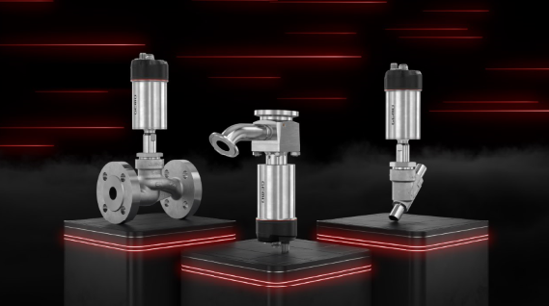
Left and right GEMÜ S40 as globe and angle seat valve, in the middle the tank bottom valve GEMÜ P40. All products are equipped with the electrical position indicator GEMÜ 12A0.

About us
The GEMÜ Group develops and manufactures valves, measurement and control systems for liquids, vapours and gases. GEMÜ is a global market leader when it comes to solutions for sterile applications.
The globally focused, independent family-owned enterprise was founded in 1964. In 2011, Gert Müller took over as Managing Partner together with his cousin Stephan Müller, becoming the second generation to run the company. In 2023, the group of companies achieved a turnover of over 580 million euros and currently employs more than 2,500 people worldwide, including around 1,400 in Germany. Production takes place at eight locations: In addition to the two production sites in Germany, GEMÜ manufactures its products in Brazil, China, France, India, Switzerland and the USA. Worldwide sales are handled by 25 subsidiaries and coordinated from Germany. GEMÜ is active in more than 50 countries on all continents via a dense network of trading partners.
Please visit www.gemu-group.com for further information.

