12th December 2024
New standards in pressure measurement systems for the semiconductor industry

With the new GEMÜ C33 HydraLine pressure gauge, GEMÜ – the valves, measurement and control specialist from Ingelfingen – is presenting an innovative solution for the demanding requirements of semiconductor production. As the successor of the tried and tested GEMÜ C32 Hydra-Dry, the new pressure gauge offers an optimized combination of precision, reliability and flexibility. Thanks to its ceramic sensor and an innovative sealing concept, the GEMÜ C33 HydraLine sets new standards in process monitoring.

With this innovative pressure gauge, GEMÜ is offering an ideal solution for the reliable monitoring of filters, precise back pressure control and the precise measurement of liquid levels. Furthermore, the GEMÜ C33 HydraLine enables high-precision pressure monitoring in numerous process applications.
The centrepiece of the GEMÜ C33 HydraLine is its new sealing concept, which is innovative and unique on the market. A ceramic sensor is used here, in which separation of media takes place without transmission fluid as a transfer medium; this is designated as a "dry system". This avoids contamination of the process medium in the event of a leakage.

The ceramic sensor is also characterized by its high resistance to chemicals, and ensures precise measurement results even under extreme conditions.
A key feature of the new sealing concept is the complete envelopment of the sensor and electronic system by a PTFE sensor sheath. This design manages without media wetted O-rings and substantially reduces the number of separation points. Furthermore, the thickness of the diaphragm significantly delays diffusion.

The new GEMÜ C33 HydraLine pressure gauge will impress you with its compact design, and can be effortlessly integrated into existing systems and plants. The modular design enables space-saving use on valve blocks and facilitates future system expansions. In addition, the fact that compatibility with the predecessor GEMÜ C32 Hydra-Dry has been considered makes the changeover easier for existing customers.

Two installation versions are available for maximum flexibility: The in-line version allows the sensor to be easily integrated into the piping, without the risk of air cushions that could lead to errors of measurement. With the dead-end version, the sensor can be replaced while the process is running – ideal for plants that are in continuous operation.

With the GEMÜ C33 HydraLine, GEMÜ is offering a future-proof solution for process monitoring in semiconductor production.

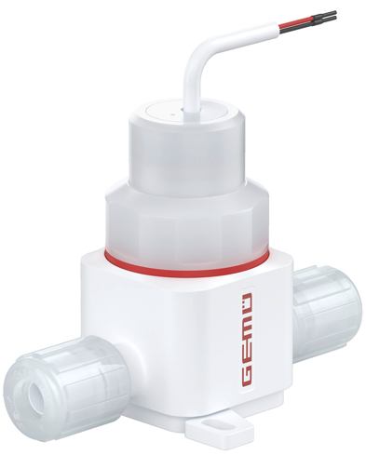
GEMÜ C33 HydraLine

About us
The GEMÜ Group develops and manufactures valves, measurement and control systems for liquids, vapours and gases. GEMÜ is a global market leader when it comes to solutions for sterile applications.
The globally focused, independent family-owned enterprise was founded in 1964. In 2011, Gert Müller took over as Managing Partner together with his cousin Stephan Müller, becoming the second generation to run the company. In 2023, the group of companies achieved a turnover of over 580 million euros and currently employs more than 2,500 people worldwide, including around 1,400 in Germany. Production takes place at eight locations: In addition to the two production sites in Germany, GEMÜ manufactures its products in Brazil, China, France, India, Switzerland and the USA. Worldwide sales are handled by 25 subsidiaries and coordinated from Germany. GEMÜ is active in more than 50 countries on all continents via a dense network of trading partners.
Please visit www.gemu-group.com for further information.

